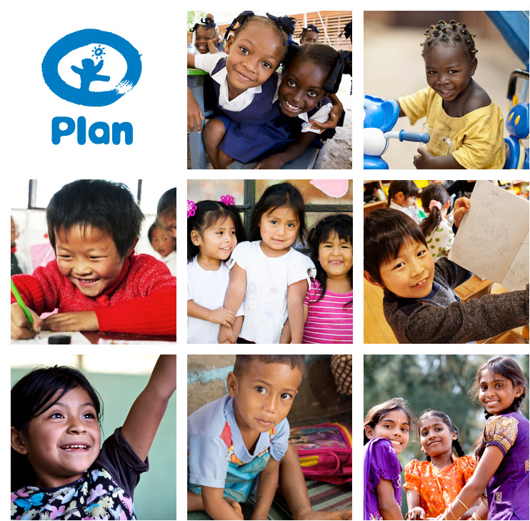

Request for Proposals
Legal Services for Plan International Sudan

[July 1st, 2021]

Plan
Plan is one of the oldest and largest children's development and humanitarian organisations in the world. Promoting child rights and working to lift millions of children out of poverty, Plan has offices in 70 countries worldwide, including in 50 developing countries across Africa, Asia and the Americas, where the large majority of Plan’s 9,500 staff are employed. In the year to 30 June 2012, Plan raised US$850million and reached 83million children in 89,000 communities.
Plan is an international not-for-profit organisation with no religious, political or governmental affiliations. Its work is principally funded by donations from members of the public, although grants from governmental and multilateral donors are an increasingly significant part of its income.
Plan’s field operations (Country Offices and Regional Offices) and its International Headquarters are all part of the Plan International, Inc. group (known as PIan International), the clear majority of offices being branches of Plan International, Inc.
Plan International Sudan is a branch of Plan International, Inc. and is registered locally with the Government of Sudan, Humanitarian Aid Commission (HAC) as an International Non-governmental Organization (INGO). The Country Director is responsible for legal issues within Sudan, subject to compliance with Plan International’s Legal Standards and other requirements set by Plan’s International Headquarters.
Appointment of legal advisor
To help satisfy its legal needs, Plan International Sudan is seeking proposals from qualified Legal Advisor to provide legal services. The types of issues the successful legal Advisor may be called upon for are shown in the table below. Any appointments made will be subject to periodic review to ensure continued quality of service and value for money.
Typical Issues
Banking and Finance
Children’s rights
Commercial Litigation
Contract and Commercial
Employment
Immigration
IT
Media
Not-for-Profit law
Real estate
Regulatory and compliance
Tax
Working with Government

Criteria
Proposals will be evaluated against the following criteria:

- License of Practicing Advocate.
- Minimum 15 experiencer in practicing advocate
- Fees/cost and value for money (bearing in mind that Plan is a not-for-profit organisation);
- Ability and capacity to handle our specified legal needs;
- Experience in advising International NGOs;
- Quality of service offered and reputation; and
- Ability to pro-actively keep Plan up-to-date with any relevant forthcoming legal changes.

Deadline for submission of proposals July 15th, 2021
We would be happy to discuss this request and answer any questions you may have during the process. You can contact Ahmed Kheir Allah who is leading this the process, email: Ahmed.kheirallah@Plan-international.org; tell: 0900931393.
Next steps
If you would like to submit a proposal, please feel free to do so in writing, ensuring that you provide details about the following:
- License of Practicing Advocate.
- Minimum 15 experiencer in practicing advocate.
- legal areas/specialisms covered. Please identify any gaps in relation to Plan’s stated legal needs that you will not be able to cover.
- Proposed lead lawyer, key contacts/team members.
- Relevant experience, including specific experience of advising international NGOs.
- Details of how you will ensure that you pro-actively keep Plan up-to-date with any forthcoming legal changes
- Languages spoken.
- Fees/rates (and details of additional charges/taxes not included in these) and how you propose to charge (e.g. hourly rates or fixed fee), including details of any discounts offered.
- Details of procedures for dealing with any client complaints and/or disputes relating to fees.
- Confirmation of the level of professional indemnity insurance.
- Your proposed terms of business.
- Any other relevant details.
Please submit your proposals by 15th July 2021 before midday 12:00 am to:
Plan International Sudan, Building #26, Block#12 Al Amarat St.#27, Alimtidad East - Khartoum city, bidding box.
Thank you for your interest.

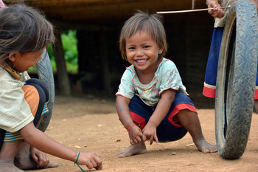
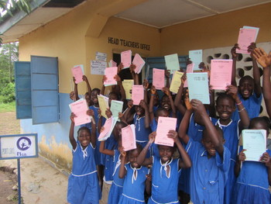
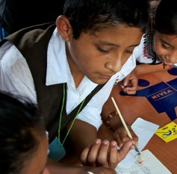

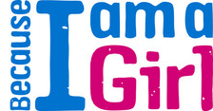

www.plan-international.org

